Order Of Service

Singing: Psalm 34—CW page 80

Reading: Psalm 119: 105-112

Opening Hymn: TLH 648

Reading: I Peter 2:11-17

Request Hymn: CW Supplement 702

Reading: Luke 12:13-21

Sermon Hymn: TLH 477

Sermon Text: Acts 20:1-16

Eutychus—A Deep Sleep

Prayer

The Apostles’ Creed, TLH page 12

Holy Communion

The Lord's Prayer

The Blessing

Closing Hymn: TLH 577

************

Bible Study: Lambs:
Sheep: Deut. 20:1-20
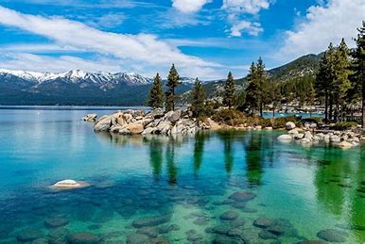

Summer In America

Water
Of
Life

8 June 2025

W A T E R O F L I F E

Independent Christian Church—Conservative Lutheran Doctrine

Worship Service: 9:30 a.m.

Larry Cooper, Pastor E-Mail address:
lcooper@wateroflife.cc
Web Site:
www.wateroflife.cc

* * * * * * * * * * * * * * * * * * * * * * * * * * *

Sermon Text: Acts 20:1-16

Eutychus—A Deep Sleep

* * * * * * * * * * * * * * * * * * * * * * * * * * *

1 And after the uproar was ceased, Paul called unto him the disciples, and embraced them, and departed for to go into Macedonia.
2 And when he had gone over those parts, and had given them much exhortation, he came into Greece,
3 And there abode three months. And when the Jews laid wait for him, as he was about to sail into Syria, he purposed to return through Macedonia.
4 And there accompanied him into Asia Sopater of Berea; and of the Thessalonians, Aristarchus and Secundus; and Gaius of Derbe, and Timotheus; and of Asia, Tychicus and Trophimus.

5 These going before tarried for us at Troas.
6 And we sailed away from Philippi after the days of unleavened bread, and came unto them to Troas in five days; where we abode seven days.
7 And upon the first day of the week, when the disciples came together to break bread, Paul preached unto them, ready to depart on the morrow; and continued his speech until midnight.
8 And there were many lights in the upper chamber, where they were gathered together.
9 And there sat in a window a certain young man named Eutychus, being fallen into a deep sleep: and as Paul was long preaching, he sunk down with sleep, and fell down from the third loft, and was taken up dead.
10 And Paul went down, and fell on him, and embracing him said, Trouble not yourselves; for his life is in him.
11 When he therefore was come up again, and had broken bread, and eaten, and talked a long while, even till break of day, so he departed.
12 And they brought the young man alive, and were not a little comforted.
13 And we went before to ship, and sailed unto Assos, there intending to take in Paul: for so had he appointed, minding himself to go afoot.
14 And when he met with us at Assos, we took him in, and came to Mitylene.
15 And we sailed thence, and came the next day over against Chios; and the next day we arrived at Samos, and tarried at Trogyllium; and the next day we came to Miletus.
16 For Paul had determined to sail by Ephesus, because he would not spend the time in Asia: for he hasted, if it were possible for him, to be at Jerusalem the day of Pentecost.

